**Assignment 3**

**1. Is there any OOA artifact missing in the figure on Slide 17 of B4DomainModeling? If yes, identify any of the OOA artifacts illustrated in the figure that this missing artifact has a close relationship. Use an example to explain your answer.**

There is one other main OOA artifacts missing from the figure on slide 17 of B4DomainModelling, which are an activity diagram. The activity diagram would have a close relationship with the system sequence diagram. An example activity diagram could be one which shows the activities involved with our bookstore example. This would show how each action performed by the user would flow to another chance for the user to initiate another action. It would show how all of the activities are connected and related, which is similar to an SSD that does not go into as much depth for each activity, but rather includes a wider variety of activities.

**2. After finishing the design of sequence diagram for the “Remove Book” use case (the next problem), discuss what OOA artifacts have helped you producing the sequence diagram . What other OOA artifact(s) could have been helpful should they be available for you to use.**

A fully-dressed use case description and an SSD are both useful OOA artifacts for creating sequence diagrams. The former helps us to understand and outline how a specific task is carried out step by step, and the latter helps us to see the high-level interaction between the user and the system for the given task, encompassing the same steps as the sequence diagram but without separation of classes/objects. Other OOA artifacts that could have been helpful are use case diagrams and a domain model. The former would allow us to see how the objects/classes are related, and the latter allows us to see how the classes interact with each other as well as the functions available.

**3. For the "Remove Book" use case, a fully-dressed description was produced in Assignment 1 and a system sequence diagram was produced in Assignment 2. They provide useful information to produce a sequence diagram for the "Add Book" use case. Assume that object interaction takes place among instances of four classes. While class “OrderItem” has the operation to retrieve the book ID for any item being selected by a user in the lower section of the “MainWindow”, “BookOrder” provides the operation to, when the user takes the action, remove a book from the list in “OrderItemList”. This operation of “BookOrder” also returns a true value if the list of order items becomes empty after book removal. Use Visual Studio to produce a sequence diagram named “RemoveBook” based upon your fully dressed “Remove Book” use case and system sequence diagram.**

OrderItem has the operation to retrieve the book ID for any item being selected by a user in the MainWindow BookOrder provides the operation to, when the user takes the action, remove a book from the list, OrderItemList BookOrder also returns a true value if the list of order items becomes empty after book removal

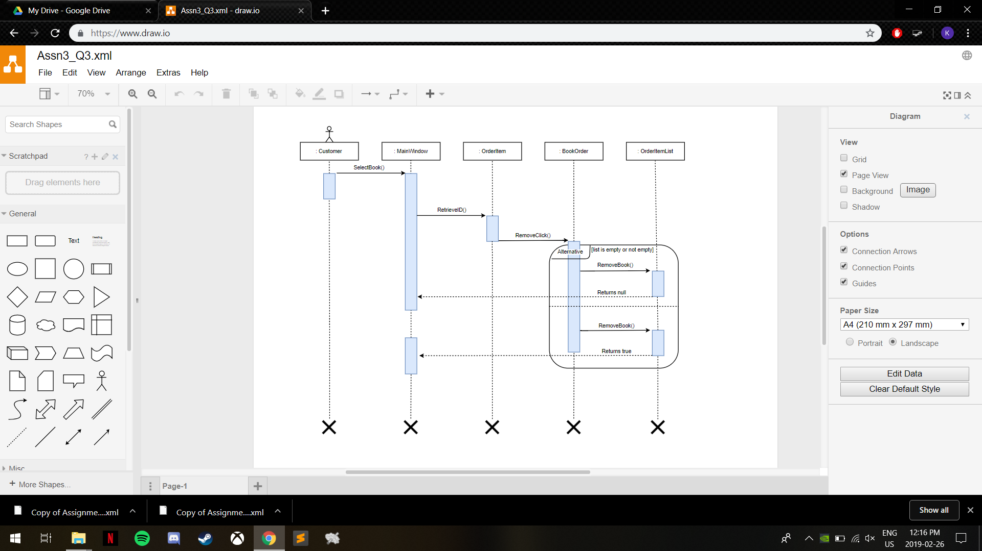

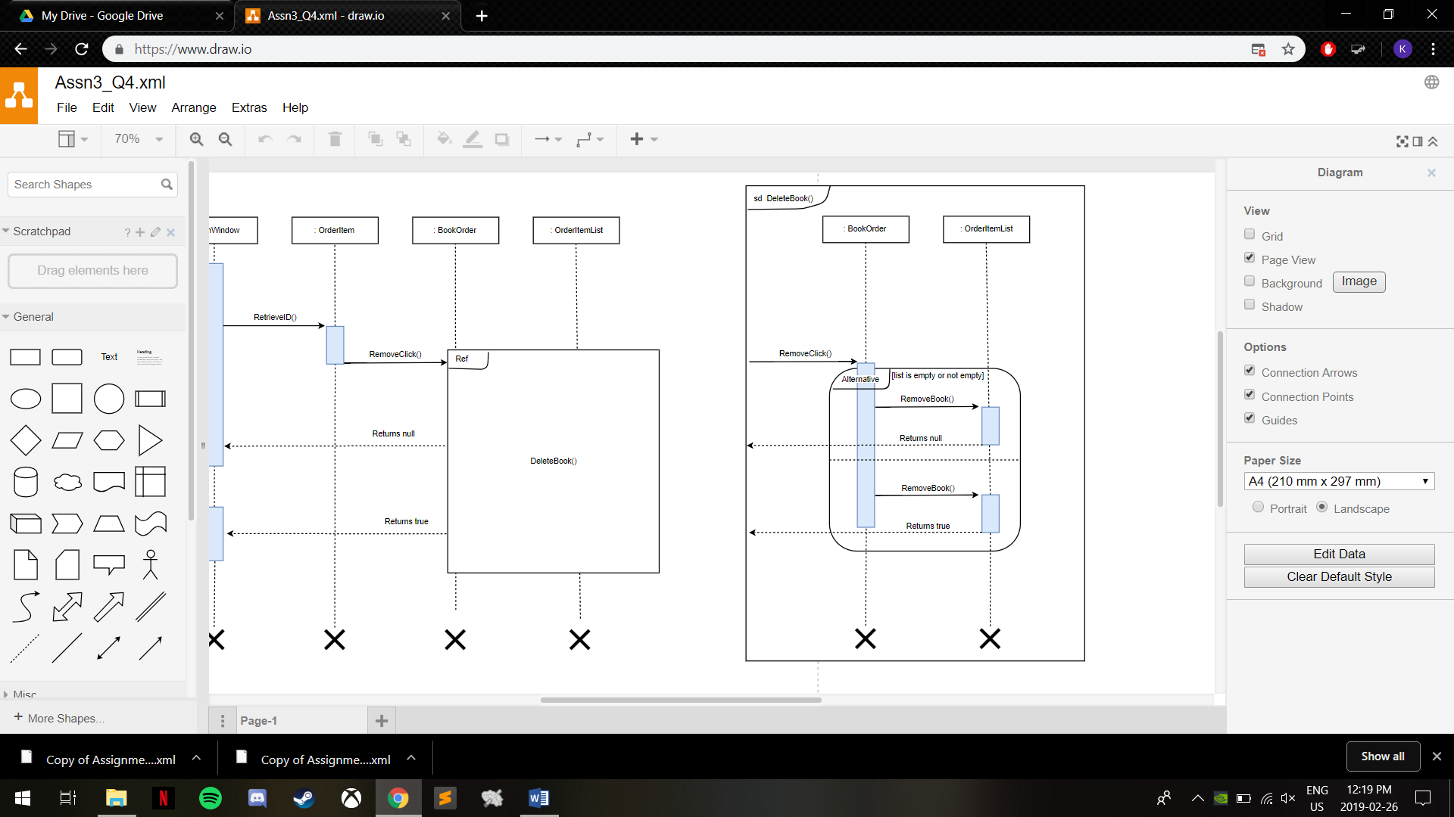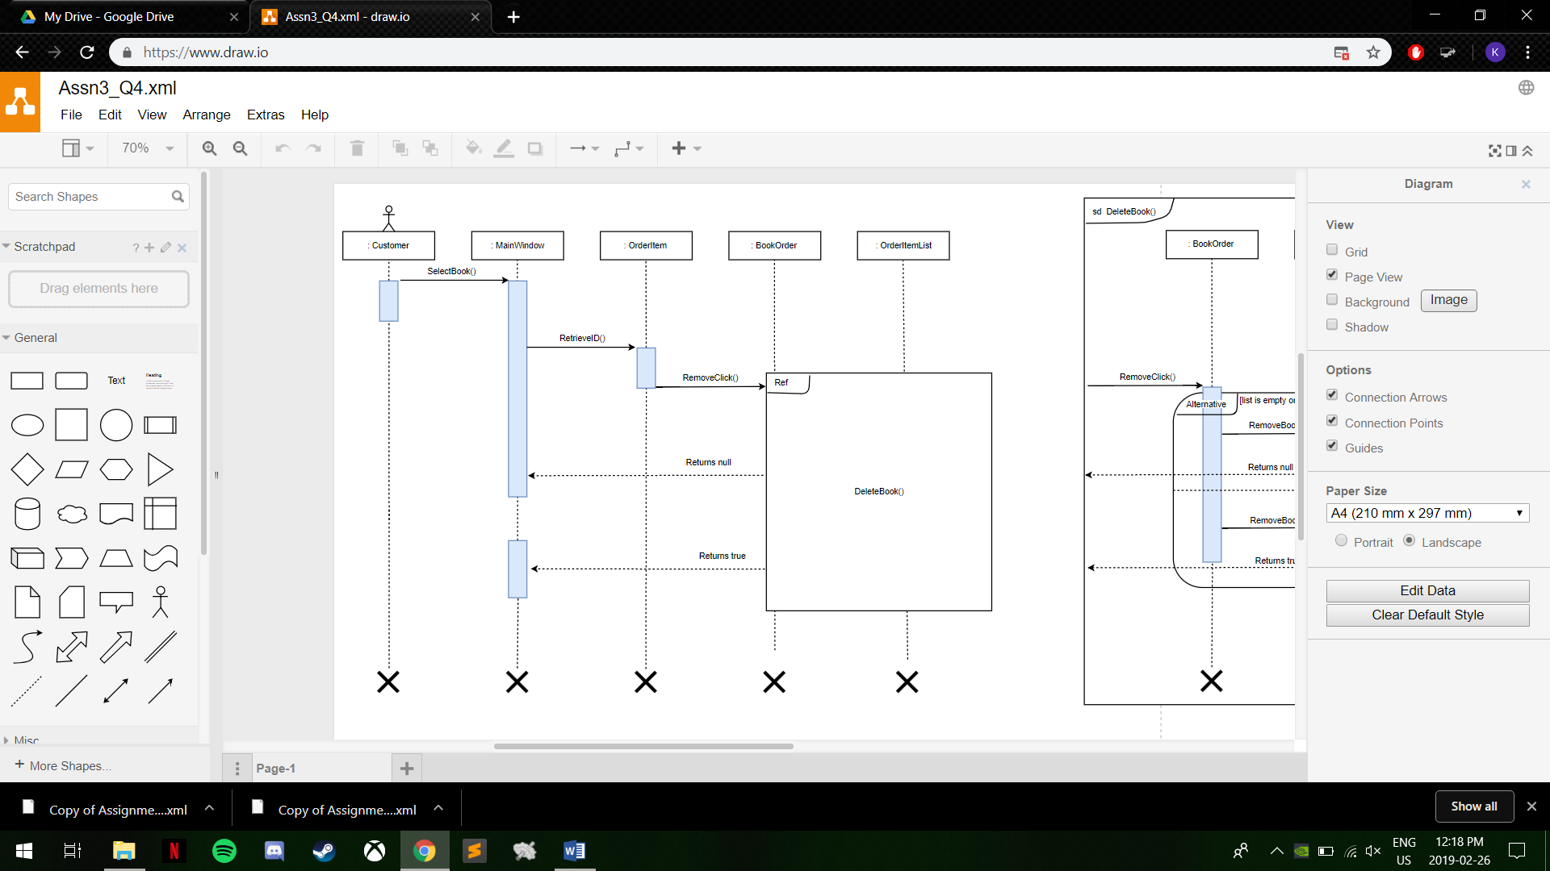**4. For the purpose of exercise, separate from your “RemoveBook” sequence diagram the group of interactions involved in the removal of a selected book “BookOrder”, including the request from “MainWindow”. Place this group in a sub-sequence diagram called “DeleteBook”, and then refer back “DeleteBook” in an updated “RemoveBook” (main) sequence diagram.**